**Assignment 3: Mitesh Sharma**

**___________________________________________________**

* Follow the steps in the below link to replicate the example: <https://maven.apache.org/guides/getting-started/maven-in-five-minutes.html>
* Take a screenshot for the command “env” and attach along with the example screen’s in a word document.
* For a good grade, you can come up with any other maven example with detailed explanation.

**______________________________________________________**

msharma: sudo yum install maven

maven installed

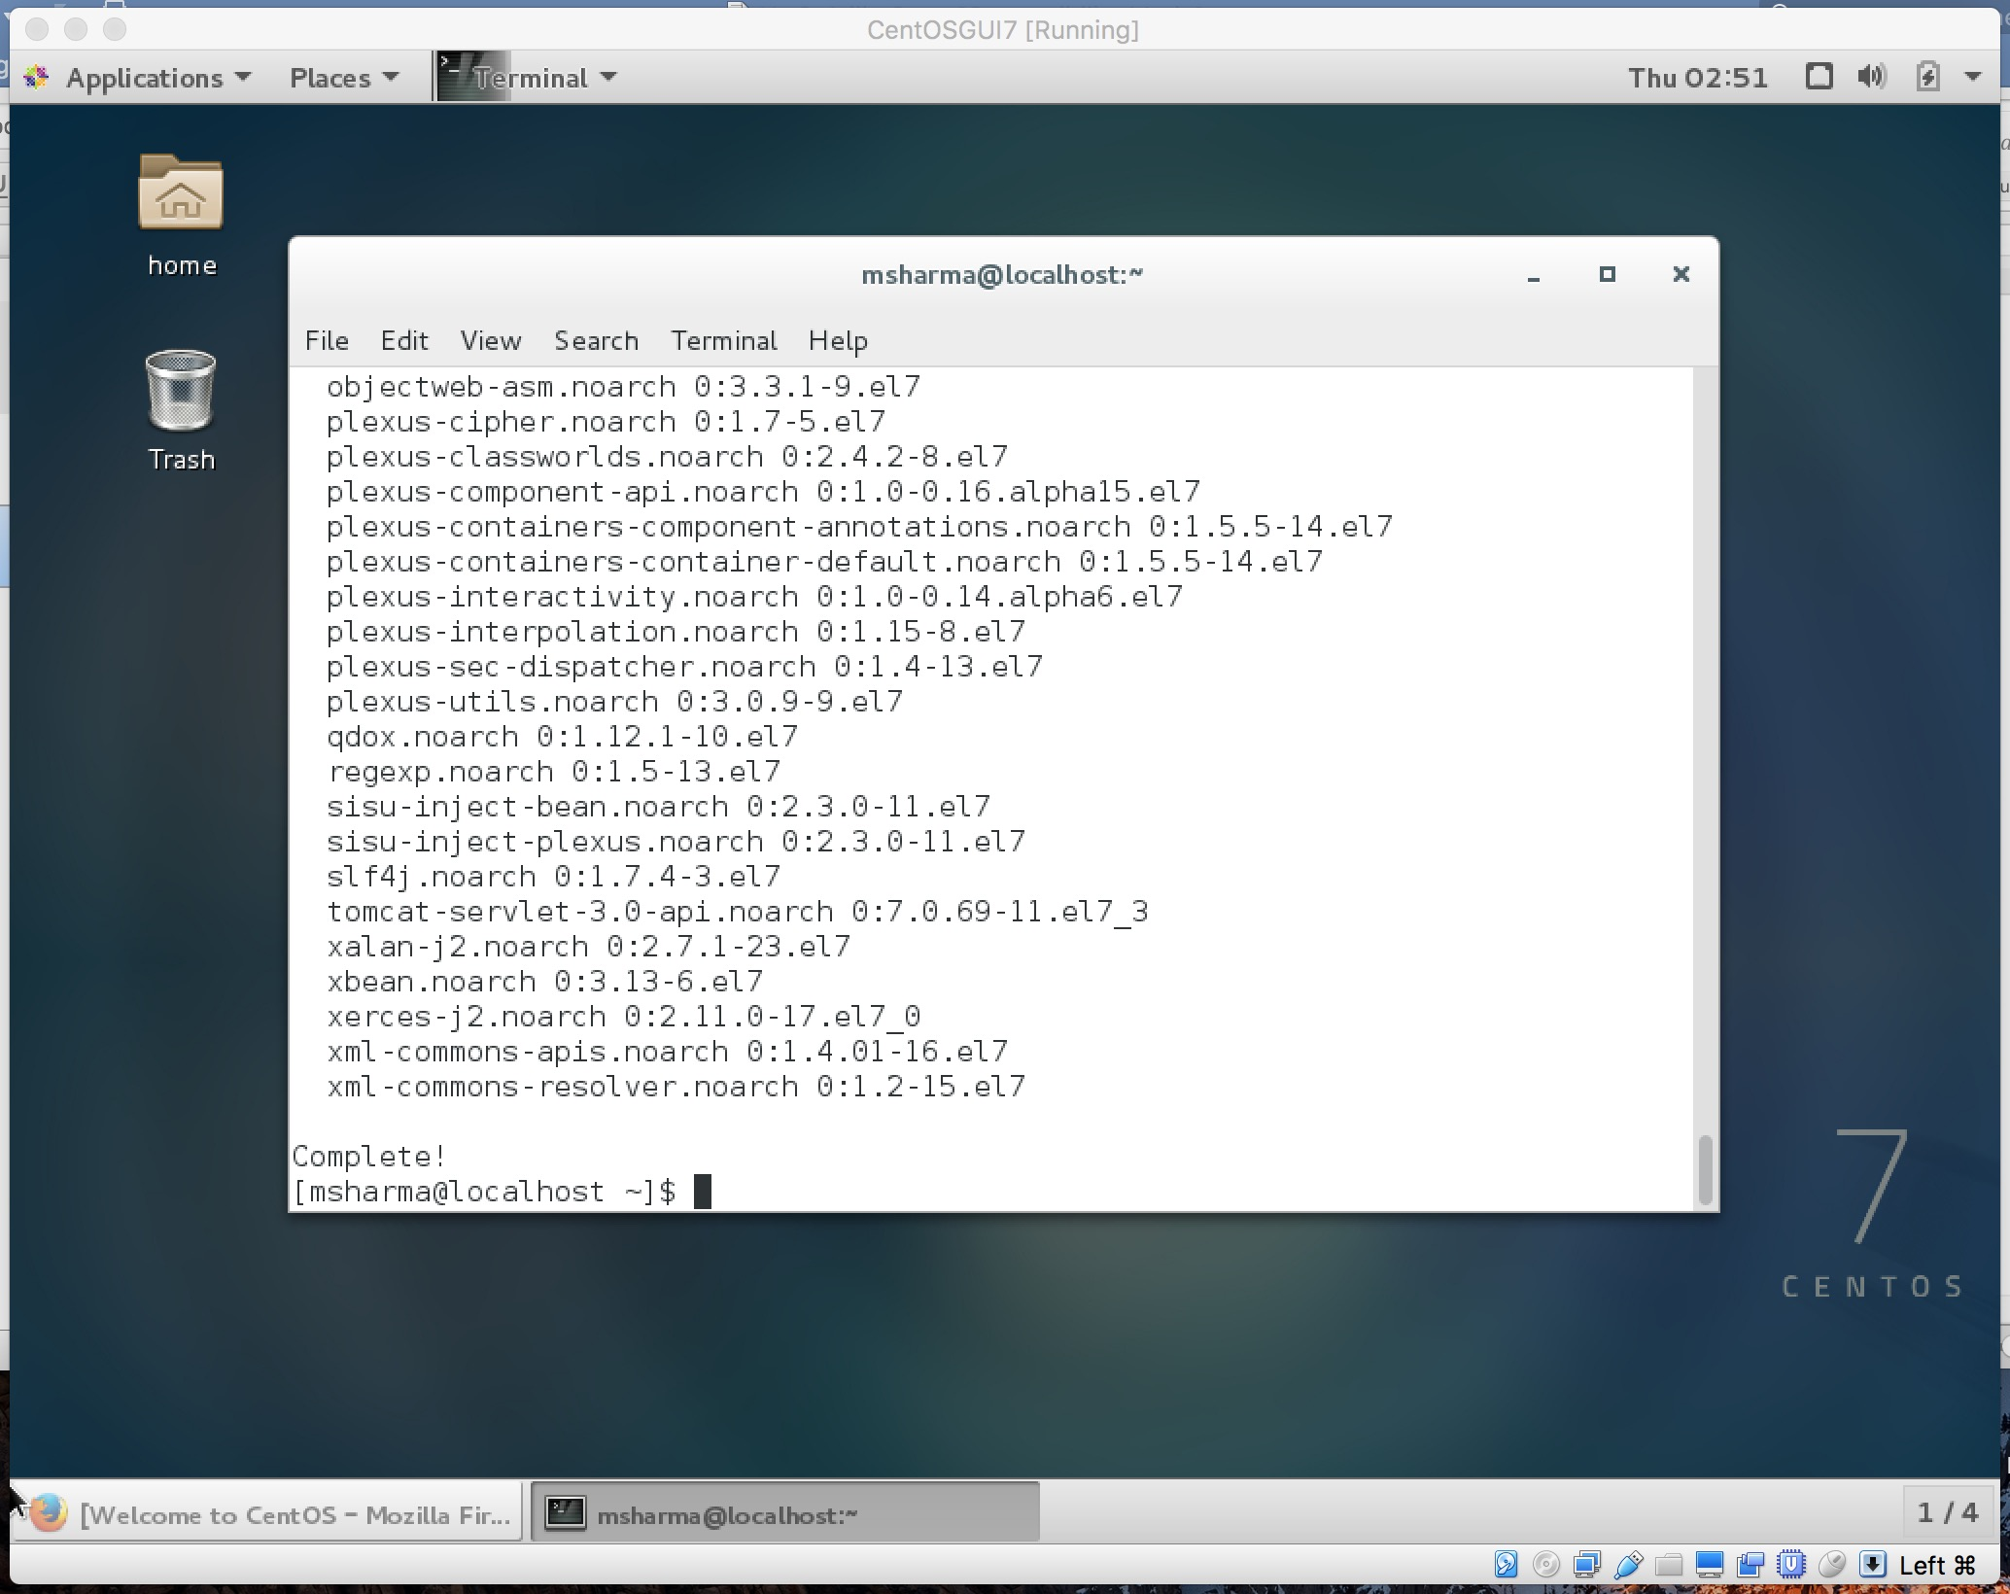

mvn --version

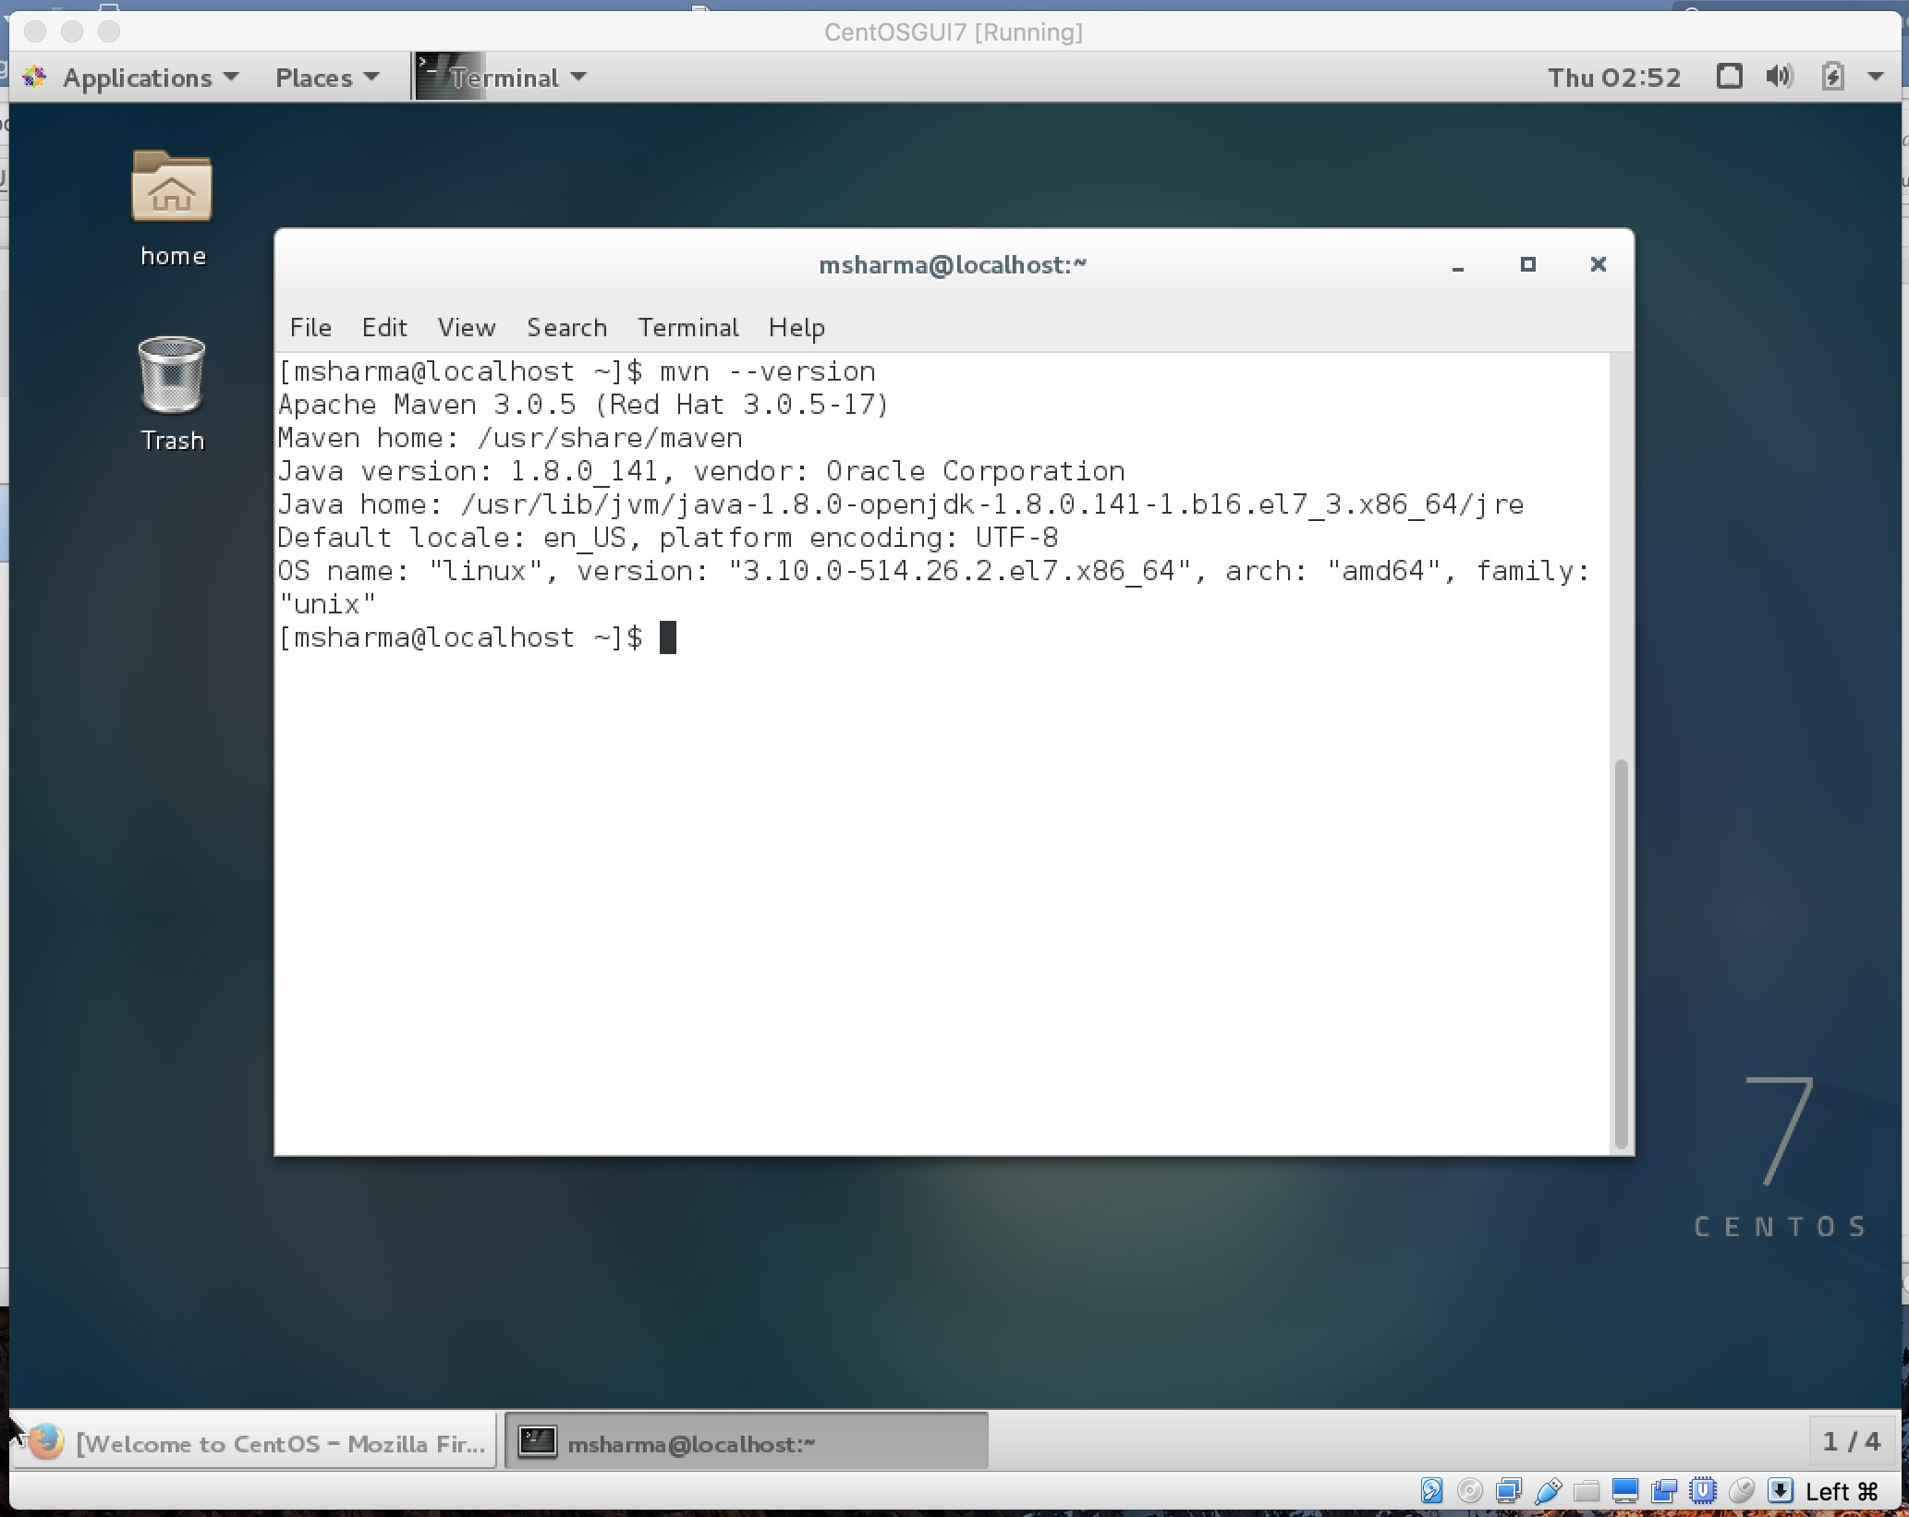

env

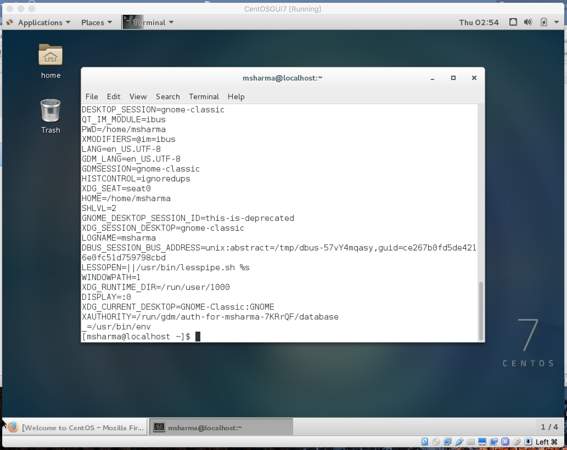

Project

cd my-app

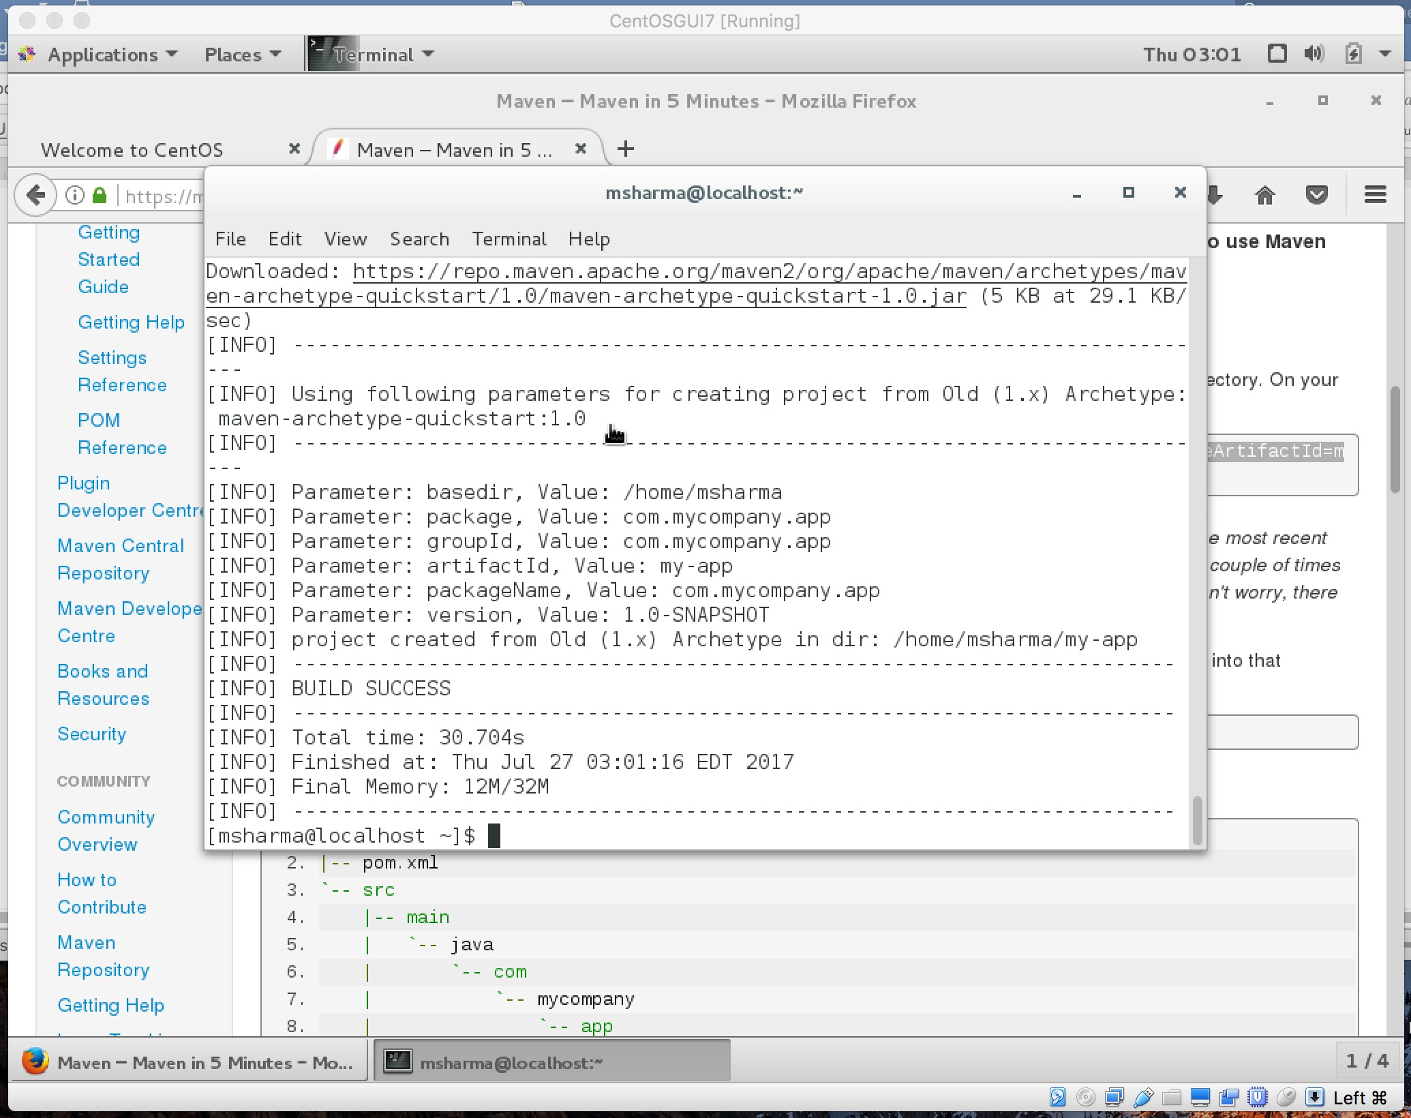

mvn site

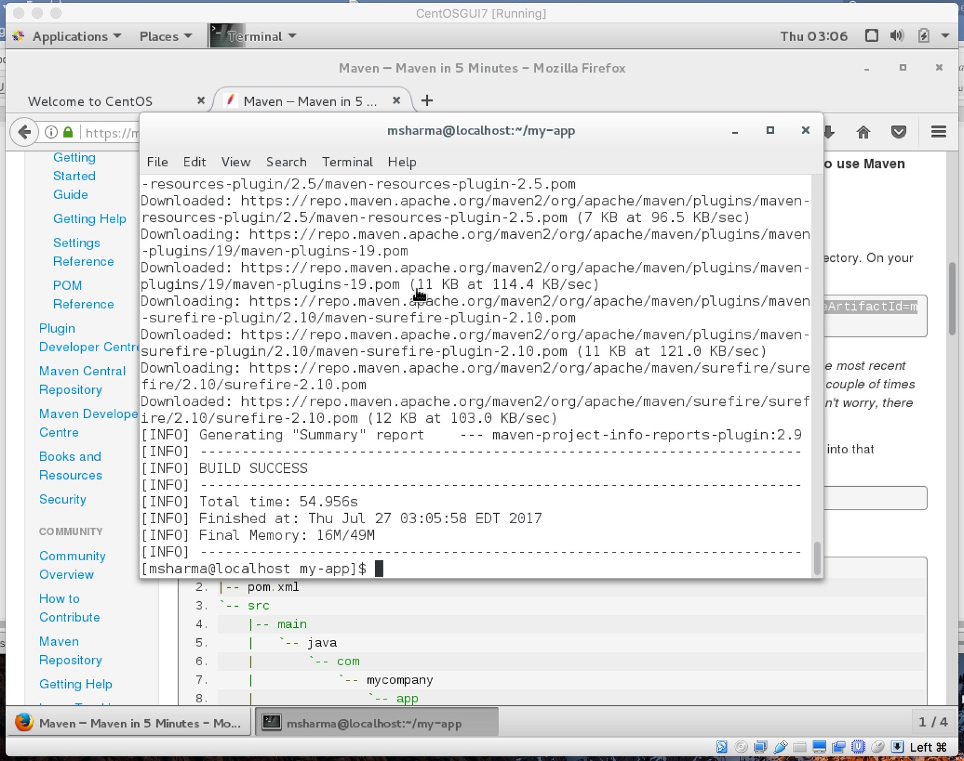

env

